Group Number: G27 | Score: _____/_____

Module Code: EE106 

Module Title: Engineering Design for Software Development 1

Report Title: Electric Vehicle Consumption

Interim Report / Final Report / Other (specify): Final Report

I/We hereby declare that this work has not been submitted for any other degree/course at this university or any other institution and that, except where reference is made to the work of other authors, the material presented is original.

Author #1: Ben Hyslop Contribution: 70%

Author #2: Brandon Bow Contribution: 30%

Date: 13/02/24

Table of Contents
1 Introduction 2
1.1 Project description: 3
1.2 Decomposition of project 3
1.2.1 Splitting the problems: 3
1.3 Testing 5
2 Reading the CSV file 5
2.1.1 3 phase load calculations: 6
2.1.2 New data frame usage: 6
Defining timestamps: 7
3 Extracting usage patterns and useful features: 7
3.1 Monthly usage: 8
3.1.1 Getting the total sum of energy used: 8
3.2 Aggregate spent monthly in Germany: 8
3.2.1 Price of energy In Germany: 9
3.2.2 Showing overall spent: 9
3.3 Standard Deviations: 9
3.3.1 Making data frames: 10
3.3.2 Getting out the standard deviation: 10
3.4 Displaying Information: 10
3.4.1 Energy used per month chart: 11
3.4.2 Spent against month graph 12
4 Event Detection Algorithm 12
4.1 Identifying Charging Patterns: 13
4.2 Analysing Time Usage Trends: 13
5 Statistical analysis 14
5.1 Comparing EV and mains: 15
5.1.1 Getting the max value: 15
5.1.2 Getting the time: 15
5.2 Seasonality: 16
5.2.1 Gathering the information: 16
5.3 Displaying the information: 16
6 GUI 17
6.1.1 While loop 1: 18
6.1.2 While loop 2: 18
7 Conclusion 18
8 References 19
9 Appendix A: Code Listings 20

Introduction

Around the world, many countries are attempting to reduce decarbonisation from transport due to the COP26, which is the 26th United Nations Climate Conference that took place in Glasgow in November 2021. In the UK more than a quarter of carbon emissions come from transportation[1]. To reduce this statistic many are switching to electric cars.
The electric car was first made in the early 19th century and was first popularized around the late 1990s and early 2000s and has been growing in use ever since[2]. These cars usually run on rechargeable lithium-ion batteries and only need to be recharged every 2-3 days depending on the amount its used[3]. This type of consistent usage can affect the energy grid and market of different countries. It can affect not only how much we spend but also how much pressure is put on the energy grid. If the energy grid is put under too much pressure it could waste more fossil fuels just trying to make that energy. If not dealt with properly it can become much more of a severe problem in the future. The way most nations have their grid set up is to only be able to run a full capacity for short periods throughout the day. These times follow a similar pattern every day, with their being a domestic fluctuation followed by an industrial spike between the standard working day and then another spike from 6 pm after the working day has ended and people return home. Overnight the grid mainly sits idle because of the little demand whilst the majority of people sleep. If there was a major shift towards EV vehicles becoming the most used type of vehicles, then there would be a major need on the grid to be running at all most full capacity overnight when the vehicles would be charging for use during the day.

Project description:
This project is focused on gathering useful data and statistics on EV (electric vehicle) consumption and then displaying it effectively. The data shown will accurately tell the user the peak energy use times, aggregate energy use, money spent, etc. The user should be able to use this information to see if the current grid can cope with the integration of EVs into a power grid using a technique like load shifting and see if there would need to be any upgrades necessary.

Decomposition of project

Splitting the problems:
To effectively show a series and amount of data to a user the interface, legends, labelling of data and finding the data must be easy to use and understand. This all starts with how the code is made and shown. The code should be streamlined and easy to read. To do this we are splitting the individual main problems into distinct functions and then calling them when the user asks for them. For example, the data detection algorithm. If we give the user, the option to look at event detection data we could show when evP usage goes above 0 by graph and then show things like the average length of charge and the longest and shortest charges on a table.
For now, we aren't using a class and having the data read file function as a parent function because we feel it isn't entirely necessary for what we’re trying do. Using just functions makes the code more streamlined and easier to read whereas if we used a class, it could get quite messy when trying to make the user interface. Instead, we are making the variables global and then making new variable (tables) inside the functions.

def over_u():
global overall_use
overall_use = ...

def Mon_use():
monthly_usage = ... overall_use
print(monthly_usage)

The snippet of code above is an example of how we are using functions. The first function being the parent, creating a variable that is usable in every other function across the stretch of code. Like in the function Mon_use() for example, a new variable is created with the original variable and presented to the user.

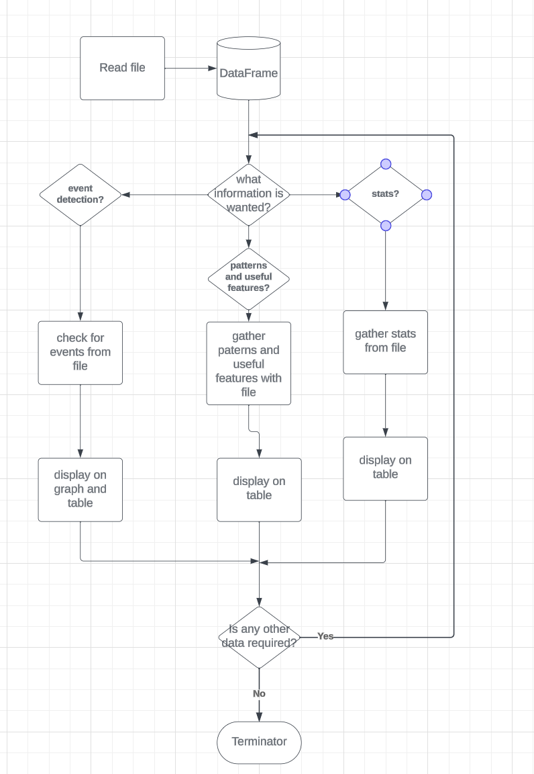
Figure 1 flowchart

As shown in the figure 1, it highlights each function (problem), how they are being split and how they are representing the individual data from each problem. We tracked what needed to be done in each function on GitHub and made to-do lists for each function as shown below. The read file function puts all the csv data into readable data and outputs it. Next the user is asked for what data is wanted out of the data frame. This is so they don't have to constantly scroll through countless tables and charts of information. Next whatever data has been asked for will be represented in the most efficient manner. To make sure all needs are met the user can decide at the end if he wants to look at more data or if he just wants to end the program.

Testing

When testing large amounts of code very common and useful methods are Whitebox and Blackbox testing. Whitebox and Blackbox testing are similar but not the same. Black box testing is used for examining the deepest parts of the code by fully understanding it and testing it based on how well it performs on certain criterions. This splits into two things functional and non-functional testing. Functional testing involves comparing outputs with expected outcomes, checking boundary conditions, and validating user flows. Non-functional testing examines how quickly the code will respond to certain commands and how stable it will be. Whitebox testing examine the codes performance based on the user. So the person putting in variables will only see the outside of the code not the inside. This allows to test errors and bugs within the code aswell as what kind of variables might be expected from users interacting with the code. First the code was tested with Blackbox functional testing to examine the in-depth parts of the code. Almost 90% of the code was examined in this test and came out successful. However, there was one error with the monthly spending. Originally the hourly rate was being multiplied by the monthly and therefore gave an in accurate set of data. To fix for this error it is shown in 3.2.1.Next with the non-functional testing the performance of how quickly and stable the code responded to certain commands it reached a high of 0.7s to display information after putting in a request. As well a low of 1.5s to display graphs however this only happened 2/10 times the code was tested in this manner. Finally with Whitebox testing multiple users were brought in to play with the code and GUI. This trial came out mostly successful however with slight bumps. The only problems that occurred were within the GUI that didn’t take any errors into account. For instance, if the wrong variable wanted was not put in correctly the code would either stop completely or go immediately back to the start of the loop, both cases were not desired with inputs selected.

Reading the CSV file:
Completed: Ben Hyslop
Data frames are tables or sections of data variables that have been tracked or measured against another variable like time and can be manipulated using a programming language. Research labs for instance, in some cases will track their results against time and then use that data to further represent their research. When analysing and manipulating data it is essential to first understand it. What does each data plot represent? Do these columns make sense? When we know the answers to these questions, we can go on to manipulate the data further and get out more detailed and universally usable data.
To analyse the data first we need to read and manipulate the current csv file and put it into a data frame called ‘research_collect’. To do this we used Panadas ‘read_csv()’ [1] function that looks at the desired csv file and separates and labels the data by the columns originally put in the file. Labelling the columns is also automatically taken from the csv file. These names can be changed frequently using the ‘.rename()’[1] function. An example of its use is shown below.

df = df.rename(columns= {'oldName1': 'newName1', 'oldName2': 'newName2'})

Across the current file being used, there was data taken every minute between 01:00 am on 01/01/2021 and 11:04 pm on 31/12/21, a total of 364 days and 22 hours, tracking 1 household’s use of an electric car charging port in power (W) across a 3-phase load in germany. It also holds what the main 3-phase load was at the time as well.
This problem did not just consist of one function, as previously stated this read file needs to be easily manipulated later. 3 phase loads aren't easy to manipulate so first we needed to find the total power used from the 3-phase load across the mains and the charging port and add that to a new data frame. Next, we will want to use this data frame for the rest of the project since it's the easiest to read. This involves two things, making use of the total power used and being able to read the timestamps.

3 phase load calculations:
When finding out different variables like current and voltage from a three-phase load it requires much more complex calculations than just multiplying or dividing due to the phasor angles needing to be considered. Fortunately, the data collected is in power (W) so we can just add all three columns for mains and evP’s together. To make this even more simple we can just put our added values into separate variables for each column.

total_ev = research_collect['evP1'] + research_collect['evP2'] + research_collect["evP3"]

total_mains = research_collect["mainsP1"] + research_collect["mainsP2"] + research_collect["mainsP2"]

As shown in the snippet of code above we are first accessing the evP columns of the original data frame that has read the file and adding all three together. These calculations are then put into their own respective variables specifically labelling each calculation.

New data frame usage:
To make any new data frame there are two options. One way is to make a new csv file which is the equivalent of brute force and the definition of inefficient, because you’d have to first write in the entire file into the code and then read this separate file. The other and much more preferred option is to use the ‘.assign()’ function from pandas [1]. This function allows us to add variables into the data frame in their own columns and label them separately.

overall_use = research_collect.assign(total_evP_used = total_ev,total_mains_used = total_mains)

The snippet of code above is an example of this. We are making the new and easier to read data frame by first calling the new data frame ‘overall_use’. Next, we put into this data frame the original data frame as well as the new column’s that we just made using the ‘.assign()’ function previously mentioned. The function first requires the columns name hence the ‘total_evP_used =’ and ‘total_mains_used =’. Using these labels, we can then add our data into these columns specified. We added the data using the variable names of the specified calculations mentioned before in 2.1.1.

Defining timestamps:
If timestamps aren't defined it causes a lot of problems later into the project in terms of efficiency and being error prone. There are multiple very complex and rough ways of converting timestamps into something more readable however, thankfully pandas have helpful functions that can deal with this certain type of problem. One function is the “to_datetime” from pandas Api [1] which reads the timestamp data and changes it into more readable data. Now with this function we can gather data at specific intervals.

overall_use['timestamps'] = pd.to_datetime(research_collect['timestamps'])

As shown above we are casting our timestamps column into a more readable data series by first specifying the timestamps column as a variable under the current data frame we want to change it in. Then cast it by calling the pandas function and inputting our desired variable, ‘timestamps’. The good part about the function “to_datetime" is that it doesn't make a completely new column, so there won't be two-time variable columns shown inside of our data frame.

Extracting usage patterns and useful features:
Completed: Ben Hyslop

Monthly usage:
Monthly consumptions are a data variable which consists of the total amount something is used across an entire month (30,31 days). A monthly usage of electric consumption for instance can be used in a variety of ways. In cases where we want an average use or in this case, how much is used at certain times it is good to use time variables like use per; second, minute, daily, monthly, and yearly. This can help to narrow down where the most use is and when. This amount of data can also lead to the user being able to find more accurate patterns of energy usage and lead to a quicker response in load shifting.
First looking at this problem it seems like a simple for loop will work which will just add up all the numbers in a certain range and get out the total sum. However, this is not only a very large amount of code but very complex. The other issue is how to then get out the total amount used and show it for which month.

Getting the total sum of energy used:
First, we need to sum the total usage together for the month and present the data at the columns of each month. One trial as previously mentioned was using a for loop, and after tackling the biggest problem and then allowing us to use a for loop the new problem of how we added in the columns for which months came up. What would have been needed was 12 separates for loops from January to December with twelve separate variables and then putting them into an entirely separate data frame. Thankfully, the function ‘.groupby()‘ in pandas [4] is much more efficient. Although it doesn't take away the problem of having to make a new table set of data, we can still sum all the data together.

monthly_usage = overall_use.groupby(pd.PeriodIndex(overall_use['timestamps'], freq='M'))[['total_evP_used',"total_mains_used"]].sum()/1000

The snippet of code above is the groupby function being used in our code. The first thing to notice is that there is another function ‘.PeriodIndex()‘ inside the groupby() function from pandas Api [4]. This function is the main thing that allows us to take away the for loops. What it does is it takes one set of time series variables set before the freq variable by a colon and then group the column’s according to whatever is put inside the freq variable. In this case we put capital ‘M’ as we want to group the data into months. If we put capital ‘Y’, we would get our columns grouped by years and if capital D, columns would get grouped by days. Second is the calculation being put into these grouped columns. The total power used from the evP and mains is being separately summed together with the ‘.sum()’ function and divided by 1000 to read kw used. This collection of functions is Then put into a separate table variable called ‘monthly_usage’.

Aggregate spent monthly in Germany:
The average price of energy in the Uk is 28.62p per kwh [6]. That totals to over a grand per year for most households in the UK. When looking at consumptions of energy it is good to see how much money is spent per consumption to see where you might need to cut down if you wanted to save money. Smart meters for example show how much you have spent per usesage of energy or gas and allow its users to budget well. On a large scale it can be very important to budget so knowing how much is being spent per month or daily can be helpful. The user can also use this to find peak uses in an area or just see how much money will be available. The current data set that is being used is from Germany so the total amount will be in euros.
The problem is a lot more basic than it first seems. First it involves grabbing the average cost of kilo watt per hour in Germany and multiplying that by the overall energy used in an hour. Next, we want the option of converting these hourly values into monthly values and presenting that in the same data frame.

Price of energy In Germany:
The average price of energy in Germany was 32.62 cents for kilo watt per hour during 2021[7]. We are using the 2021 rate since that's when the data we are currently manipulating was taken. To get the value of hourly spendage first the current evP used values need to be grouped by the hours. This can be done with the previously used function’s ‘.groupby()’ and ‘.PeriodIndex()’ [4], then getting out the hourly values. Then by doing the same thing as before when getting the total evP and main used we got out the total of how much evP used costed as shown in the snippet of code below.

a = overall_use.groupby(pd.PeriodIndex(overall_use['timestamps'], freq='h'))[['total_evP_used',"total_mains_used"]].sum()

t = a.assign(total_cost=a['total_evP_used']*0.3234)

Again, we just create a new data frame like with the currently being manipulated data frame. We are calling this new data frame ‘t’ and adding in a new column. Then in this column we are making our calculations inside of the assign function. Now every hour in the year the evP used will be multiplied by the 2021 German kwh rate.

Showing overall spent:
To show the overall spent on energy the hourly rates must be put into months because if we were to show all the hourly spendages in a year that would just be inefficient and not very easy to read or use. To do this we can just add the total cost column from before into the ‘.groupby()’ function for the current table we are displaying all information from the problem on. Then all the data in that column will just be grouped monthly along with the total EV and mains used. It will also be noted that the total cost is in k euros as to not confuse other readers.
The only issue with this is that after converting the currently manipulated table the first time into hours the timestamps column becomes an index data type and is no longer a timestamps data type. This means that we can no longer change this value. If we wanted to change these values into months one way that has previously been mentioned is the use of the csv library but as mentioned before as well this is very inefficient. The other way is using another fancy function from pandas that has prepared for such an occasion. This function is similar to the function we used to convert the timestamps. ‘t.index’ [4] This function looks at the index variables that are passed through it and allows us to iterate them. So instead of using ‘pd.PeriodIndex’ to get the monthly we just use the ‘t.index’ function.

Standard Deviations:
Standard deviations are commonly used in statistical analyses to show random patterns. There are two types of standard deviations. Population and sample. Population is to be used when we have all possible values of what we want to get the standard derivative of. In this case we do so the population calculations is most appropriate. In the stock market for example many traders use standard deviation of a certain stock to determine whether it is good or bad. The use of this practice increases the probability of how much profit can be made and also saves traders from massive losses. When looking at load shifting seeing the random pattern of when energy is being used and when the main supply is being pushed to its limits we can determine when we want to relieve the energy grid of unneeded pressure.
Giving the most data possible is essential to relieving the grid of this type of pressure so first it must be noted that there are no grouped data frames in days. Currently we have only shown data in months and done calculations in hours and what use would the standard deviation of energy be good if it was only in months. So, an additional data frame in days must also be made. Then we must get out the standard deviation in months, days, and hours.

Making data frames:
After a while of making different data frames, it becomes a very simple task. Making the days data frame is just again just doing the same as before from 4.1.1.

hours = overall_use.groupby(pd.PeriodIndex(overall_use['timestamps'], freq='h'))[['total_evP_used',"total_mains_used"]].sum()

months = overall_use.groupby(pd.PeriodIndex(overall_use['timestamps'], freq = 'M'))[['total_evP_used','total_mains_used']].sum()

The snippet of code above shows the creation of our useable data frames. To specify a second month data frame is being made to not involve a standard deviation in cost. It just wouldn't be needed.

Getting out the standard deviation:
The current standard deviation population formula is given as $sd =\sqrt{\frac{\sum_{ }^{ }{{\left(x_{i}+\overline{x}\right)}^{2}}}{N}}$.
Since we do have all the possible hours, days, and months inside of a year we can use this formula which gives out the most accurate data. This formula could be done manually using a for loop and multiple other separate functions however this requires not only another library but also a whole lot of lines of code. Especially considering we want the standard derivative for three different time variables. Instead, we can sum it down to three lines of code for each timed data frame that been made and put them through the ‘.std()’ [4] function. This function is another of panda's handy functions that help with dealing with this kind of data.

sd_h = hours.std()

sd_d = days.std()

sd_m = months.std()

This is an example of how we are using this function. The sd in each variable stands for standard deviation and the letters associated with them are the time variable’s there with. According to the pandas Api [4] if the entire data frame is called through the function that can still be considered the same as the standard deviation population.

Displaying Information:
After doing all these calculations it is important to display all this in an appropriate fashion. When showing data comparison like spendage or usage per month’s the best display is usually a bar graph. Tables or scatter graphs require the user to think more in depth about what the highest value actually is. The data should instead be quickly and easily understood. A bar chart is an x-y plane graph that splits groups of data and what limits they reach. For example, in figure 3 shown below. It displays how one group is above another very clearly.
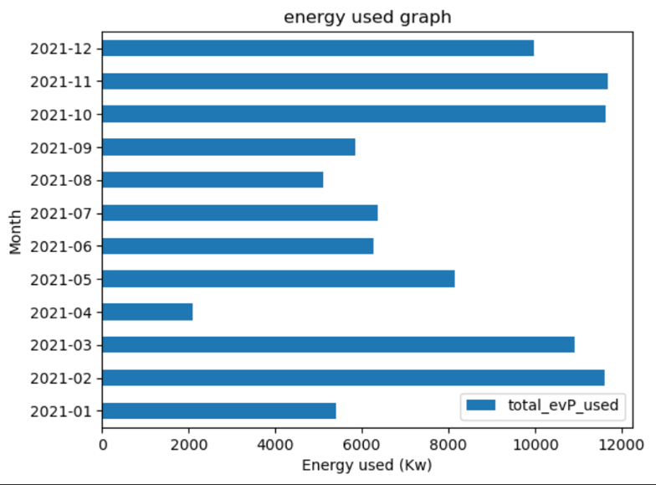
Figure 2: Monthly use graph
Accountants use this type of data visualisation to show investors or their bosses their overall or expected growth in a certain region. They give the investors a good idea of what they're getting into as well as showing their bosses what areas should be focused on as well as what parts might not need as much attention.
If in the case where the user may have to skim through this data, they can quickly find the month with the highest usage or spendage or even what time variable has the biggest deviation. A bar graph allows for these criteria to be met. In python there are multiple libraries that can take data and automatically create graphs like TensorFlow, plotly and matplotlib[5]. The library that was chosen was matplotlib due to the simplicity of it. Plotly and TensorFlow are a bit more complicated and isn't as easy to implement with pandas. This problem is a one-way thing and only requires displaying one table with usage and another with spendages.

Energy used per month chart:
To make the energy usage graph first the matplotlib library had to be imported in as plt. This was for simplicity rather than writing out matplotlib every line of code. The chart was made with the function ‘.plot()’ from the matplotlib library [5] and applied in the snippet of code below.

(months['total_evP_used']/1000).plot(kind = 'barh')

As shown first we are grabbing the monthly evP used and dividing it by 1000. This is to display the data in kw which is easier to read than having the scientific notation in the corner. Nex the plot function is being used as mentioned before however there is an additional function inside of this. The kind variable is what allows us to define the type of graph/chart that we want. Is used to make it a horizontal bar chart. If we wanted to make it a vertical chart, we could just take the ‘h’ out and leave ‘bar’. The graph that was displayed was the same as figure 2

Spent against month graph
The spendage graph per month was made in a similar way however to get the total cost separately we are using the time frame from 3.2.2. The snippet of code below is an example of how we have applied it.

x['total_cost'].plot(kind = 'bar')

As mentioned, before we are using the same function and line of code however what must be noted is that x variable is the time frame from 4.2.2 and has already been divided by 1000. Hence, the graph will be displaying k Euros on the chart as shown in figure 3.
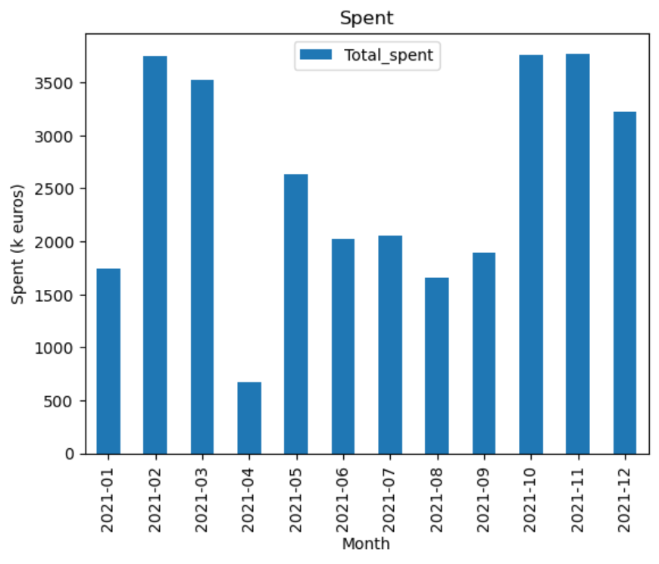
Figure 3:Monthly spent graph

Event Detection Algorithm :
Completed: Brandon Bow
Implementing an algorithm to detect when the household is charging their vehicle is a crucial step in this project. For example, the car won’t be charged constantly which means there will be lots of data that isn’t relevant and will need to be filtered out. However, there will need to be different times when every line could be relevant and therefore multiple algorithms will be required. Event detection algorithms can be used to identify charging patterns, usage trends, highlight anomalies or breaks in patterns & optimize the efficiency and energy management of the user. Implementing the algorithm is to help analyse the data so to do this through the code using functions such as ‘groupby( )’ grouped with the ‘mean( )’ function allows the data to be separated by previously defined variables which is what allows specific calculations to be made separately and combining all of these is what will combine this sections and allow the user a well-rounded view on the data.

Identifying Charging Patterns:
This is potentially the most important use of the algorithm. Understanding the trends and frequency of when and how long EVs are charged is the main way of analysing any potential changes required to the power infrastructure that may be required to keep up the demand of the shift towards increasing reliability and use of EVs as well as allowing energy companies manage this shift in demand efficiently. The algorithm will analyse the patterns of charging such as peak charging times, frequency of charging – such as length of charges, or how many times per week or month. To identify the patterns of charging we had to figure out how to identify when charging started.

To identify when the EV started charging we identified in the data when evP1 went from 0 to a positive value greater than zero. This was accomplished by:

#Detecting evP1 Usage
transitions = (df['evP1']>0) & (df['evP1'].shift() == 0)

Scanning evP1 use, the script looks at the field "evP1" in the DataFrame, which shows how much energy the EV uses. For each row in the DataFrame at any given time, it compares two numbers to find the exact moment when the EV starts to charge: Does the EV use electricity? This is what it does: In this case, df['evP1']>0 means that the EV is using energy and charging from the mains supply. Up until now, did the EV not use any power? If df['evP1'].shift() == 0, it means that the number in the row before it was zero. If it was, the EV just started charging now because it wasn't charging before. From that point on, any row that meets both conditions starts a charging process. This means that each row has a set of True or False values that are saved in transitions and show where these cases of starting to charge are.

#Filtering Filtered Data
transitions_dates = df.loc[transitions,'timestamps']

We get the exact start time of a charge from this line of code by selecting the data. To do this, it first gets the "timestamps" from rows in the DF where transitions are "true," which means that a charging session has started. The product is a list called transitions_dates that shows exactly when the EV began charging.

Analysing Time Usage Trends:
Analysing usage trends allows a change in the operation of the current to suit the needs of the consumers. The trends tend to dictate the price of energy at certain times. Highest usage times = most expensive. If there was a major shift towards EVs then the night-time drop-off would be less noticeable and potentially cause an even larger spike in usage and price. Analysing the usage trends can help those making decisions on the supply side of the operation on things such as price make more informed decisions. When analysing trends in Python the library Pandas provides helpful functions for forecasting as well as analysing the trends. Throughout the code, we used the function ‘df.groupby( )’ [1] to group data together by time periods. These time periods can be grouped by what label is put in the brackets for example: ‘df.groupby(timetsamps)’ or ‘df.groupby(evP1)’. These inputs are linked to the columns in the data file and perform analysis based on these inputs. We used this because it makes completing these calculations easier because of the efficiency and flexibility of the functions, which is perfect for our projects where we are constantly calculating different

days_with_energy_used = days[days['total_evP_used'] > 0]

mean_days_per_month_with_energy_used = days_with_energy_used.resample('M').size().mean()
print(mean_days_per_month_with_energy_used)

This code provides an understanding of the average days per month spent charging. It does this by analysing the ‘days’ dataframe which is a time period for energy usage across 1 day.
A DataFrame is a complex data structure that is two-dimensional, has named axes (rows and columns), and can vary in size.[2] Similar to a key in a dictionary, an index in a pandas DataFrame serves as a label for each row and facilitates quick access to data. It is the main method by which pandas provide effective searching, merging, and grouping functions as well as data alignment. Each row in a DataFrame is uniquely identified by its index value, which is normally an integer, a text, or even a tuple. A Pandas index cannot be changed directly after it is created since it is immutable. This feature protects the data structure's integrity during operations that could otherwise cause the data's alignment to change, commonly known as an immutable array.

The first line acts like a filter for excluding any data where ‘total_evP_used’ has a value less than 0, meaning we are only left with data where energy was used. ‘days_with_energy_used.resample('M').size().mean()’ creates a filter by month separating them into monthly bins. The ‘.size( )’ function then calculates the size of the groups (number of days with energy usage per month) and the ’.mean( )’ function calculates the mean value of these monthly groups finally giving the average number of days per month with usage. This code focuses on eliminating irrelevant data out of the calculations giving as accurate a representation as possible. Also splitting the data into monthly bins continues to create an efficient and more concise section of code to make analysing the data as easy and effective as possible, which ultimately was why the Pandas library was chosen.

Visualising the Number of Daily Charging Occurrences:
This visualisation shows the distribution of EV charging times based on the dataset. The objective is to present the daily number of charging sessions. Changing the "timestamps" field in the given dataframe (df) into a datetime object makes it easier to manipulate the date and time data.[4] A function named "plot_charging_events" is used to visualise the charging events. It takes a DataFrame named "events_df" as a parameter. The data is shown visually in a histogram, which is made by this function. This line is used to find out when the EV begins drawing power from the main supply. It does this by recognising charging transitions. The "evP1" column, measures power usage, and when transitions go from 0 to a positive number this is achieved. When taking the date part from the "timestamps" column and adding it to a new column called "date" in the DataFrame. It is important to sort the information by day. To find out how many charge events happened each day, we had to group the data using the data of extracting the start of charging and then count how many times this happened. When plotting the histogram to show how the number of daily charging events. The histogram also gives a simple visualisation of the code working and gives the user a clear picture of the data. Lastly, the "plot_charging_events" method is called with the DataFrame df as its argument, which starts the task of visualising the data. This code looks at data about EV charging and provides a. visualisations that demonstrate how often charging events happen per day. This gives us useful information regarding time the usage trends of an EV vehicle.

Detecting Breaks in Patterns & Anomalies:
The algorithm was meant to be used to flag when the usual patterns of the other calculations are broken. This could be anything from a shorter or longer than-normal charge to a change in charging patterns – which could be investigated further to find any potential technical faults or if it is linked to the weather or time of year. However, this section never got completed due to several reasons but mainly because of the difficulty of trying to carry out a problem like this. The difficulty when attempting to find breaks in the trends or anomalies when looking at energy consumption data, especially for a project that only focuses on one household. These problems happen because of the nature of the data, the complexity of underlying behaviours, and technical limitations. One example is the wide range of factors that can affect energy use, like the habits and preferences of the user, this can make breakage in patterns unlikely because of the small chance of users that would change their behaviour. If this was based on more than one house's usage then these differences would be more prevalent. As we will speak about later in the report seasonal effects are another big factor that can make it hard to spot irregularities. These effects are closely linked to energy use and can naturally change with the time of day, the week, and the season, which wouldn't be considered an anomaly just a change in general behaviour based on external factors. Some technical issues, like the amount of detail in the data and how it is shown minute-by-minute, hourly, or daily, can also make it harder to find differences or breaks in trends due to the sheer number of pieces of data that need to be processed, many of which would be irrelevant to the problem being faced. This kind of work gets even harder when you can't do the calculations you need to detect these patterns. Lastly, outside factors that change often, like the weather, the economy, and government policies, can also affect how much energy people use, causing changes or anomalies that aren't present in the data being analysed.

Statistical analysis
A statistical analysis is an in-depth amount of research done on a set amount of data. Production of certain services and goods are statistically analysed constantly to determine how well or how bad a company is doing at specific aspects. For example, one factory from a company could be outputting as much as possible and doesn't need as much attention or in need of being fixed. Whereas another factory in the same company could be doing very poor and the company will need to put more focus it. Changes can be applied to this factory based on the analysis and thus hopefully improve its production. With phase loading and wanting to release pressure from the grid, a statistical analysis would be very effective. Showing what the maximum energy used is and displaying the time can be very useful for the user.

Comparing EV and mains:
When wanting to relieve the grid of as much pressure as possible efficiency of using that energy must be taken into account. Seeing what time the mains supply is at its max or what time the ev consumption is at its maximum use can be very useful. This information can be split into two key areas required. First the time the supplies are at their maximum and second the value of the other. For example “The maximum value of the total power used is ‘max value’ and it occurred at ‘max time’.”. Getting this information may seem simple however getting the time of the peak is quite complicated.

Getting the max value:
First to get the max value of the ev and mains is simple but it must be considered what time is to be displayed. Showing the hour specifically as well as the exact date would be the most optimal. If it were to be done in minutes this would be too little information on the exact time it was displayed. So, to gather the max ev used and the max mains supply from the hours dataframe in section 3 as well as using the .max() function.

Getting the time:
As previously mentioned the time is to be displayed in hours rather than minutes or months. However, there are multiple ways to accomplish this. One way is to use the ‘.iloc()’ function. This function allows for manually gathering the max value in a dataframe by a set range. For instance, if it was required to gather certain values in a certain timespan it could be specified within this function. However, a more simple way is to just use ‘.idmax()’ function. This function will search for the index of a maximum value depending on the location given to the function.

max_time = hours.loc[hours['total_evP_used'].idxmax()]
max_time2 = hours.loc[hours['total_mains_used'].idxmax()]

The snippet of code shown above is an example of how the function is being used. First ‘.idmax()’ is being used to find the index of a maximum value of the ev used and the mains used. Second the .loc[] function is locating the row of this max value within the hours data frame. There is also a third function that must be used to determine the name of this row. The name would be considered as the timestamp of this max value.

Seasonality:
Seasonality is a common practice in many industries to determine periodic patterns of different very random variables like usages or different movements. Take for example a company wanting to produce a product. Designers of this product must know what the market wants via a certain period in the year or a certain online trend. One branch method of thsi is the holt-winter method. This method has three main components. First, the level which represents the smoothed level of a time series data. Second is the trend line which describes the slope or trend of a specific time series data. Third is the seasonal component whihc captures the seasonal variations. In this projects case the seasonality of ev usage is very useful. Determining the periodic pattern throughout the year helps to study when the mains might most likely be under pressure. The main problem is how should this information be displayed in the most efficient manner.

Gathering the information:
The information of a periodic pattern should be displayed in a manner that is instantly understandable by a glance. A plotted graph would be one of the best ways to do this as the consumer would be able to look at which part of the months ev usage appears to go up whereas some parts might go down. To achieve this a graph of the data plotted from the hours dataframe will be created. The reason for the hours is that minutes would be too much for one graph and months will be too small. The hours dataframe displays the data required in the most efficient manner. Another option to further simplify the graphed data would be to increase the level of the time series data. So instead of going along all values of zero the base level would be say any value greater than 5. This would be inefficient however as the data could be somewhat misleading for determining when mains isnt needed as much or just when ev chargers arent being used.

Displaying the information:
As stated before the information gathered from a statistical analysis must be well documented and easy to read. First for the comparison of the ev and mains supply max value’s, they had to be displayed via the print function. This was so the values could be understood as best as possible as shown in figure ?. Displaying this information via a table could have been another option however this did not work as trying to plot this data via a dataframe proved unsuccessful. This was because an attempt at placing the single row of this information along with the same column wasn't allowed due to index matching and column spacing in original data frame's.
Figure 4: Display of max values and time

Next was displaying a graph of the seasonality. This was accomplished by simply using matplotlib’s .plot() function. The graph was displayed as shown in Figure 5
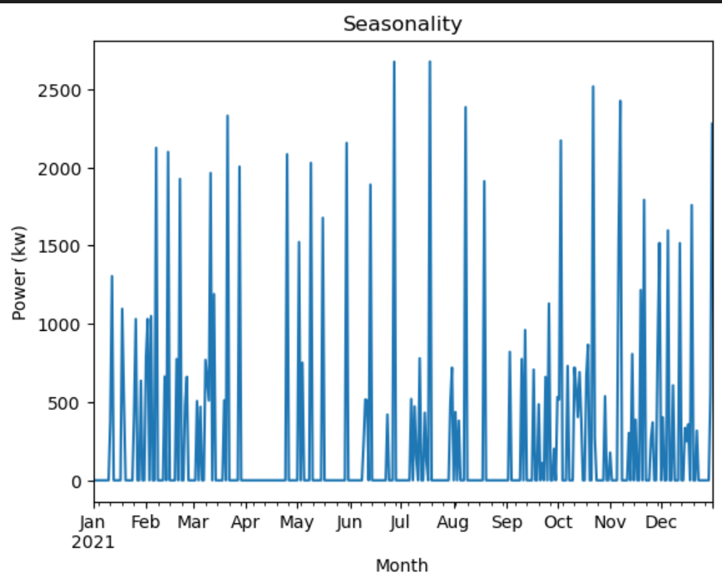
Figure 5: seasonality graph

GUI
A Graphical user interface (GUI) is an electronic interface that allows users to interact with different types of data. This type of data consists of money, consumer products, weather data, maps etc. Every good GUI allows for users to easily interact with said data and use it to whatever intended purpose. Clothing websites for instance require easy to use GUI’s to draw in more buyers. Another example is stock websites which require easy to use GUI’s to help stock traders with things like day trading. In this projects case it is similar to a stock website. Users must be able to analyse data easily and be able to reach a decision which has a good probability of reaching the desired goal. The user interface was originally attempted with tkinter however it did not display certain graphs as desired. The reason for this was with the converter function in matplotlib which would change timestamps data points into unwanted or false data. However, without the converter function the graphs wouldn't be displayed. So instead a terminal based GUI was prompted for. This split into two while loops that allows the user to navigate easily through different sets of data within the project.

While loop 1:
This loop is the base or original loop. This loop allows for the code to be started or fully initiated. This loop is set off by a previous input which asks the user if they want the data. If the input is y the loop ‘needy’ will begin. This loop is the loop that allows for code to continue even if there is an unexpected error with the input by using an else statement. At the end of the loop after the nested loop ends there is a final decision branch which asks the user if they want to collect more data. The error with this decision branch is that if the input isn't y or n the code will return to the nested loop. To fix this the nested loop is fitted with a hidden 4th decision which is shown to the user via the else statement. It was possible to use a try and except loop however this proved to be too complicated and didn't handle unexpected inputs as well as the else statement.

While loop 2:
This nested loop is a ‘not while loop’. The variable that decides whether it is finished or not is called finished which becomes a Boolean False variable. This simplifies reading and understanding the code as the code will be read out as ‘while not finished’. This is the loop that allows for the user to pick what data they want. It will print off a list and have an option of 3 decisions. These decisions are down to the 3 main tasks asking the user if they want; Patterns and useful features, event detection and statistical analysis. Once the user decides on any of the three decisions the chosen decision will call a function and display the information via the terminal. Then finished will become true and end the loop. If an unexpected input is placed then there is an else statement that explains an error has come up and requests the user to re-enter a requested input. This statement keeps the finished variable unchanged.

Conclusion

In an attempt to understand and broaden the group's current understanding of energy consumption and phase loading, using Python there has been a tremendous amount of work accomplished to manipulate and display set data within a year. Looking at who the user is and understanding what they want specifically is a good practice for real-world applications. The primary objective of the project to allow the user to be able to relieve the energy grid of pressure by displaying data efficiently and effectively was accomplished. This objective was successfully accomplished. The analysis of data patterns and the presentation of various peaks and off-peaks across the entire data set was the stage of the project that was considered to be the most crucial. This was accomplished using a variety of techniques, the majority of which utilised functions from the library’s pandas and matplotlib, in addition to ordinary Python functions. If the project were to be repeated, subsequent attempts would be made to do additional in-depth study and other statistical analyses. There was a significant lack of components in the statistical analysis, which would have been of great assistance in displaying the results. As well, a greater effort would have been made to create a graphical user interface (GUI) using Tkinter; unfortunately, the flaws could not be fixed within the time limit that was immediately approaching. Lastly, the project would be completed earlier than originally planned. To accomplish this a better time plan would be put in place. For example, a Gantt chart would have been more efficient rather than a to-do list. To conclude the group learned a sufficient amount about displaying information and understanding user wants. Although more could have been done with an extended amount of time.

References

[1]- Department for Transport, “Transport and environment statistics 2022,” GOV.UK, Oct. 20, 2022. https://www.gov.uk/government/statistics/transport-and-environment-statistics-2022/transport-and-environment-statistics-2022 [accesssed Feb. 15,2024].
[2]- K. Wilson, “The Electric Car’s History Goes Back Further Than You Think,” Car and Driver, Mar. 31, 2023. https://www.caranddriver.com/features/g43480930/history-of-electric-cars/ [accessed Feb. 15,2024].
[3]- “Autotrader - page unavailable,” Should I Charge My Electric Car Every Night? - Autotrader (accessed Feb. 15, 2024).
[4]- “API reference — pandas 1.0.1 documentation,” Pydata.org, 2014. https://pandas.pydata.org/pandas-docs/stable/reference/index.html [accessed Feb. 15,2024].
[5]- “API Overview — Matplotlib 3.4.2 documentation,” matplotlib.org. https://matplotlib.org/stable/api/index.html [accessed Feb. 15,2024].
[6]- “Gas & electricity prices per kWh in the UK,” Theenergyshop.com, 25-Jun-2019. [Online]. Available: Gas & Electricity Prices per kWh in the UK | The Energy Shop [Accessed: 20-Mar-2024].
[7]- “Household electricity price in the first half year of 2021 was 32.62 cent per kilowatt-hour,” Federal Statistical Office. [Online]. Available: Household electricity price in the first half year of 2021 was 32.62 cent per kilowatt-hour - German Federal Statistical Office (destatis.de). [Accessed: 20-Mar-2024].
[8]“Intro to data structures — pandas 2.2.1 documentation.” https://pandas.pydata.org/docs/user_guide/dsintro.html
[9]“pandas.DataFrame.index — pandas 2.2.1 documentation.” https://pandas.pydata.org/pandas-docs/stable/reference/api/pandas.DataFrame.index.html
[10]B. H, “How to read CSV File into Python using Pandas - Towards Data Science,” Medium, Dec. 14, 2021. https://towardsdatascience.com/how-to-read-csv-file-using-pandas-ab1f5e7e7b58
[11]R. M, “How To Display A Plot In Python,” ActiveState, Jan. 23, 2024. https://www.activestate.com/resources/quick-reads/how-to-display-a-plot-in-python/
[12]R. Python, “pandas: How to Read and Write Files,” Feb. 07, 2023. https://realpython.com/pandas-read-write-files/#:~:text=The%20parameter%20index_col%20specifies%20the,avoid%20loading%20them%20as%20data
[13]Codebasics, “Python Pandas Tutorial 2: Dataframe Basics,” Youtube . Jan. 2017.

Appendix A: Code Listings
import tkinter as tk
import pandas as pd
import matplotlib.pyplot as plt
def Dataframe():
global overall_use
global hours
global days
global months
research_collect = pd.read_csv("discovergyTesla1min.csv")

#gathering total power used across 3 phases
total_ev = research_collect['evP1'] + research_collect['evP2'] + research_collect["evP3"]

total_mains = research_collect["mainsP1"] + research_collect["mainsP2"] + research_collect["mainsP2"]

#putting these gathered powers into the data frame in their own columns
overall_use = research_collect.assign(total_evP_used = total_ev,total_mains_used = total_mains)
#making the timestamps actual timestamps
overall_use['timestamps'] = pd.to_datetime(overall_use['timestamps'])

#grouping data into hours
hours = overall_use.groupby(pd.PeriodIndex(overall_use['timestamps'], freq='h'))[['total_evP_used',"total_mains_used"]].sum()
#grouping data by days
days = overall_use.groupby(pd.PeriodIndex(overall_use['timestamps'], freq='D'))[['total_evP_used',"total_mains_used"]].sum()
#grouping data by months
months = overall_use.groupby(pd.PeriodIndex(overall_use['timestamps'], freq = 'M'))[['total_evP_used','total_mains_used']].sum()

def patterns_useful():

#using kwh rate in germany to find total energy spent
Multiplying_by_hourly_rate = hours.assign(Total_spent=hours['total_evP_used']*0.3234)

#grouping data frame

temp = pd.PeriodIndex(Multiplying_by_hourly_rate.index, freq = 'M')
Monthly_spent = Multiplying_by_hourly_rate.groupby(temp)[['Total_spent','total_evP_used','total_mains_used']].sum()

#standard deviations
sd_h = hours.std()

sd_d = days.std()

sd_m = months.std()

print(f'the standard deviation of energy used per hour is {sd_h}')

print(f'the standard deviation of energy used per day is {sd_d}')

print(f'the standard deviation of energy used per month is {sd_m}')

#energy used graph
(months['total_evP_used']/1000).plot(kind = 'barh')
plt.title('Month against energy used graph')
plt.legend()
plt.xlabel('Energy used (Kw)')
plt.ylabel('Month')
plt.show()

#spendage graph
(Monthly_spent['Total_spent']/1000).plot(kind = 'bar')
plt.title('Month against overall spent')
plt.legend()
plt.xlabel('Spent (k euros)')
plt.ylabel('Month')
plt.show()

def ev_det():
print('works')

def stats():
stats_window = tk.Toplevel()
stats_window.geometry('4000x3000')
#getting max and min
# Find the maximum value of variable
max_value = hours['total_evP_used'].max()
max_value2 = hours['total_mains_used'].max()

# Find the time at which the maximum value occurred
max_time = hours.loc[hours['total_evP_used'].idxmax()]
max_time2 = hours.loc[hours['total_mains_used'].idxmax()]

# Display the results
print(f'The maximum value of the total power used is {max_value} and it occurred at {max_time.name}.')
print(f'the highest point mains was at was {max_value2} at {max_time2.name}.')

#creating a graph showing when values go above 0
(days['total_evP_used']/1000).plot()
plt.title('Seasonality')
plt.ylabel('Power (kw)')
plt.xlabel('Month')
plt.show()

Dataframe()
Needy = True
ip = input('hi there are you looking for information on phase shifting? y/n')
if ip == 'y' or ip == 'Y':
print('great')

while Needy:

finished = False
while not finished:
print('1.event detection')
print('2.statistical analysis')
print('3.Paterns and useful features')
ip2 = str(input('what type of data? please decide from the choices shown below'))
if ip2 == 'event detection' or ip2 == 'Event detection':
print('event')

finished = True
elif ip2 =='statistical analysis' or ip2 == 'Statistical analysis':
stats()
finished = True
elif ip2 == 'patterns and useful features' or ip2 == 'Patterns and useful features':
patterns_useful()
finished = True
elif ip2 == 'nothing else' or ip2 == 'Nothing else':
finished = True
print('thanks')
Needy = False
else:
print('You might have mispelled or inputted something thats not an option'
,'please try again')
finished = False
ip3 = input('anything else?')
if ip3 == 'n':
print('Thanks')
Needy = False
elif ip3 == 'y':
print('reloading')
else:
print('sorry that is not another option. if you would like to exit please type nothing else')

else:
print('nani!?')

#Start & End Charging Times

import pandas as pd

file_path = '/Users/brandonbow/Desktop/UNI 23:24/EE106/Energy Consumption Project/discovergyTesla1min.csv'

pd.read_csv("/Users/brandonbow/Desktop/UNI 23:24/EE106/Energy Consumption Project/discovergyTesla1min.csv")

df = pd.read_csv(file_path)

#Defining Detection Function
def detect_charging_events(df, column='evP1'):

#Converting into Numerical Values, Identfying the Sate of Charge, Dectecting Strat & End of Charges
df[column] = pd.to_numeric(df[column], errors='coerce')
is_charging = df[column] > 0
charging_starts = is_charging & (~is_charging.shift(1, fill_value=False))
charging_ends = (~is_charging) & is_charging.shift(1, fill_value=False)

#Events DataFrame
events = pd.DataFrame({
'Start': df.loc[charging_starts].index,
'End': df.loc[charging_ends].index
}).reset_index(drop=True)

return events
#Executing & Printing Results
events = detect_charging_events(df)
print(events)

#Extracting Timestamps When Charging

#Importing Pandas Library
import pandas as pd

#Define File Path
file_path = '/Users/brandonbow/Desktop/UNI 23:24/EE106/Energy Consumption Project/discovergyTesla1min.csv'

#Reading Data File
df = pd.read_csv(file_path)

#Detecting evP1 Usage
transitions = (df['evP1']>0) & (df['evP1'].shift() == 0)

#Filtering Filtered Data
transitions_dates = df.loc[transitions,'timestamps']

#Print Data
print(transitions)

#Visualisation of EV Charging Times

import pandas as pd
import matplotlib.pyplot as plt

file_path = '/Users/brandonbow/Desktop/UNI 23:24/EE106/Energy Consumption Project/discovergyTesla1min.csv'

df = pd.read_csv(file_path)

#Reading the CSV File and Conversion Into Datetime Object
df['timestamps'] = pd.to_datetime(df['timestamps'])

def plot_charging_events(events_df):
#Identifying Charging Transitions
transitions = (events_df['evP1'] > 0) & (events_df['evP1'].shift() == 0)

#Extracting dates
events_df['date'] = events_df['timestamps'].dt.date

#Counting Nummber of Charging Occurrences per Day
charging_occurrences_per_day = events_df.loc[transitions].groupby('date').size()

#Plotting Histogram
plt.figure(figsize=(10, 6))
charging_occurrences_per_day.hist(bins=range(1, charging_occurrences_per_day.max() + 2), align='left', rwidth=0.8, color='skyblue')
plt.title('Distribution of Charging Occurrences per Day')
plt.xlabel('Number of Charging Occurrences')
plt.ylabel('Frequency (Number of Days)')
plt.show()

#Calling Function
plot_charging_events(df)

